Activity Recognition – Natural Running Motion

|  |  |
| --- | --- |
| Helder Pestana  1191595 | Nuno David Santos  2009408 |

# ABSTRACT

In this paper we describe the idea and respective implementation of assignment 4 for Software Architecture for Users Interfaces class. This assignment is based in human activity recognition, the processing of information in order to make interferences about tasks or activities that are taking place.

# INTRODUCTION

After some lost ideas and a lot of discussion we found that running has a potential for activity recognition, but still was vague. There were a lot of potential ideas that can be chosen for developing an activity recognition application, but also almost everything is implemented for runners, mainly indoors equipment.

At first we think by switching the physical sensors that are used in that indoor equipment for activity recognition sensors, but there was nothing about innovating here. This led us to think in outside environment.

When jogging or running many people have difficult to maintain a controlled rhythmic pace over time, majority tends to start too fast and never get to complete the full period they planned. So, this is a real issue and brings some challenge and innovation as we trying to achieve.

It goes to our mind immediately that music could be the most interesting way to take control of the user pace and our first thought was to control by motivation letting the user choosing playlists for worst music and best music of his preference. Although users may be able to achieve the distance and time planned, for sure that doesn’t control our user’s pace.

After some research we find that music beat and rhythm takes effect on user pace, and this is it. This report will explain measures, studies, implementation and heuristic evaluation of using songs playlist to achieve user goals when running.

# Rhythm and beat

Beat is the basic unit of music and is what determines the speed of music which reflects how we keep in time when we dance or even when we tap the foot or fingers. The speed of music is indicated by a tempo mark above the first measure of the musical score, is measured in Beats per Minute and rarely changes during a song. It can be identified in many different ways from easy identifiable drums to the most subtle of pulses emanating throughout the music.

Rhythm is the variation of length and accentuation of a serious of sounds or others events and can be described as the flow of the music over the underlying beat. Is the part of the music that is emotive and most influences our response to the music.

Ideal running music should have many musical elements and should not be just high energy repetitive sounds because can become very boring after a short while. It should contain all the elements of well composed and well constructed music with a great variety enabling the runner to run as they want.

Many people are very disappointed when they take the favorite music out on a run. They are usually filled with excitement that their music will drive them better than ever before, but they find that is not seem to inspire them or help them as much as they expected. This will be due to the fact that the beat and the rhythms are all wrong to the exercise.

# Linking BPM to running speed

We find a research already done by run2rhythm[1], so here follows the table with the results:

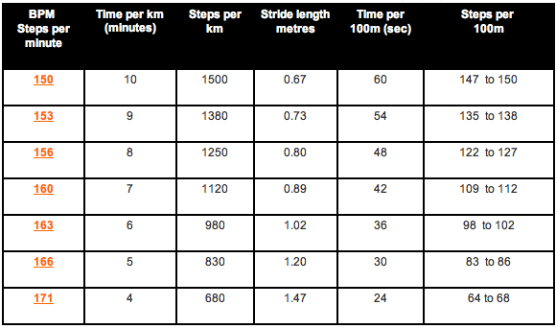

Table – Relationship between BPM and times per Km

We can see that BPM are related with the steps per minute so we can easily relate BPM with distance. With this we can easily build a playlist when user inserts a route plan.

# BEnefits

It is easy to see truly benefits from this relationship:

* Run cadence control
* Bounce in runner step
* Avoid injuries and illness
* Helping the breathing pattern
* Keeps the candence correct and reinforces the aspect of ideal running
* Better capillary blood flow
* Less muscle fatigue
* Makes you feel good

# Concept

Our concept is to connect your portable media center width some sensor in your body or accessories as Nike and iPod did[2].

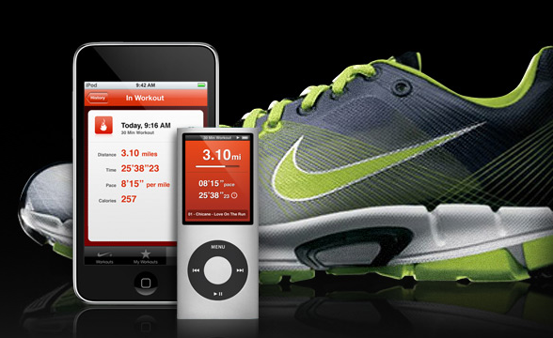

This product provides time and distance control, voice feedback and all your favorite music.

Our idea is to use runner favorite music, analyzing the BPM of each one. So when runner inserts a plan (kilometers and time) the music will be chosen by the BPMs in order to achieve the runner goal.

The sensor will be monitoring the runner activity, so if the runner gets slow or faster the playlist will change in order to compensate the runner goal, i.e. If runner get slow the playlist will pick music with higher BPM and vice versa.

# Main Goals

We don’t have opportunity neither time to build all the desire concept so our main goals will be to received data from an accelerometer of wiimote, analyze the received data to compare with step time and distance that we’ve got from the run2rhythm table in order to achieve consistency.

Also we must try to get the BPM from music in order to be able to build playlist that respects a runner plan. After the playlist done we must be able to change it in order of the received information from the wiimote accelerometer.

We have to make a full heuristhic evaluation of our concept, validating the main idea. Are the BPM really related with the steps per minute?

# Implementation

As said before, we have used a wiimote accelerometer connected to a pc by Bluetooth. Our application is developed in C# .NET framework……….

We have developed this application using php with the facebook API, which give us a social context to our application giving access to profile, friends, albums, photos, etc.

We have also used MySQL to store data that was crucial for our application to work. Our database structure is very simple and directed to the hangover information such as details, drinks, witnesses and partners.

The Facebook application also provides one self markup language: the FBML which enables our application to integrate a user Facebook experience in a simply way. With this, we can easily hook into several Facebook integration points, including the profile, profile actions, Facebook canvas, etc.

One of the first decisions was that beyond listing of hangovers, the hangover listed should be able to minimize once that the hangover tends to be a big object with several components. At the end this implementation proved itself to be a great idea, mainly with the introduction of the ability of users to comment hangovers. In this case, a hangover can turn really extensive and there were a problem if a user wants to list the hangovers. Other solution was to list hangovers and then users could select which hangover. This last solution will give one more unjustified interaction for users and consequently new bids to server.

Other great consideration was that for showing drinks and friends, it should be presented in a scroll object avoiding problems if user has many friends. The interaction of choosing drinks and friends we try to approach to the facebook handling with similar objects, so there are some javascript function that provide drink and friend selection on client side.

In order to provide easy interaction for other users, we took in consideration some features to use on user profile. From those who were available we choose to put a tab on user profile and also put a resume box in profile. The tab lists the user’s hangover while the small box gives resumed information of the last hangover. In this way every users can interact with applications from the profile

# Constrains

Our main constrains were dealing with facebook API and documentation. How can I say: Facebook documentation promises heaven while Facebook API gives us hell.

We find incoherencies between documentation and the API. Some behavior on API is completely different from those that we are used for common web based applications.

We find several problems but I cannot pass without highlighting this one:

Facebook provide a comment board that is defines as being simple to use and you do not need to put any code to make it working. So far so good, the tag name for this object, Facebook Markup Language, is <fb:comment>. Well, it really is, for the start tag, but if you end this object with </fb:comment> it will not work, it must end it </fb:board>. I never saw something like this and this gives us a lot of lost hours. In resume, this object is treated like this:

<fb:comments>

.

</fb:board>

# Future

In next version, we should allow users to insert places where user has been in order to share and to give knowledge of the best places at the identified city.

Other interesting feature is giving to user the ability of creating his own drinks. We know that are typical drinks, and this may be a great way to share regional typical drinks.

# Conclusion

What at first sight looks like a simple and easy application reveals to be complex and much more big and time consuming than we’ve ever imagine.

Although, this project reveals itself interesting and motivating, but also pushed to a hard workload to make things really nice and working.

We had concerns of every kind since documentation, who’s no always to be correct, to the API: is not clear to know how and where to use some objects and features.

At the end we are proud of our work because we can take benefit of the social network to relate physical events, i.e. bring the Facebook to the physical world.

In a short resume we can say: Users can communicate between each others through our application in a variety of ways.

# REFERENCES

1. Run2rhythm

<http://www.run2r.com>

1. Nike and iPod

<http://www.apple.com/ipod/nike/run.html>